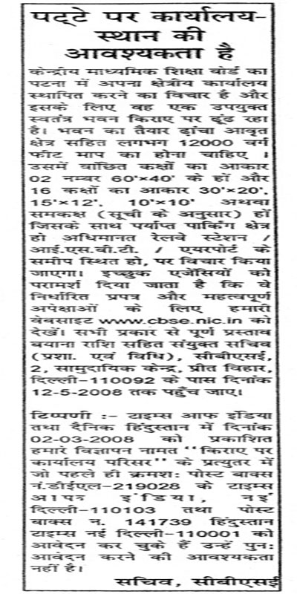
“WANTED”
OFFICE ACCOMMODATION ON LEASE

Central Board of Secondary Education intends to establish its Regional Office at Patna and is searching for a suitable independent building on rental basis. The Building should be framed structure with covered area measuring approx 12000 sq. ft. The desirable room sizes are 02 nos. 60’x40’ and 16 rooms with sizes 30’x20’, 15’x12’, 10’x10’ or equivalent ( as per schedule) alongwith sufficient parking area preferably located near Railway Station/ISBT/Air Port shall be considered. Interested agencies are advised to visit our website: www.cbse.nic.in for down-loading the prescribed format containing important requisites. Offers complete in all respect alongwith EMD must reach the Joint Secretary (A&L), CBSE, 2 Community Centre, Preet Vihar, Delhi- 110092 latest by 12.05.2008.
NOTE: Those who have already applied in response to our advertisement named “Hiring Office Accommodation” appeared in Times of India and Dainik Hindustan on 02.03.2008 to Post Box No. DEL 219028K The Times of India, New Delhi -110103 and Post Box No. 141739 Hindustan Times, New Delhi – 110001 respectively need not to apply again.
SECRETARY, CBSE
CENTRAL BOARD OF SECONDARY EDUCATION
SHIKSHA KENDRA, 2, COMMUNITY CENTRE
PREET VIHAR, DELHI-1100092

‘TENDER PROFORMA’

SCHEDULE

- Location and Address : _______________________________________
- Distance from Patna Rly. Stn./ : _______________________________________
ISBT/Air Port
- Width of approach Road : _______________________________________
- Whether the premises is approachable : _______________________________________
through public transport.
- Whether the premises is suitable for : _______________________________________
office purpose _______________________________________
- Area of Land : _______________________________________
- Total built up area : _______________________________________
- Total no. of storeys : _______________________________________
- Details of the approved plan : _______________________________________
- Details of the set-backs : _______________________________________
- Details of Rooms/Halls size/Area (copy: _______________________________________
of the plan be attached) _______________________________________
- Salient features (suitability as office : _______________________________________
accommodation) ________________________________________

- Whether expansion is feasible : _______________________________________
- Whether the building is a framed : _______________________________________
structure.
- Loading capacity of the Bldg., kg/sqmt : _______________________________________
- Details of sanctioned electricity load in : _______________________________________
KW
- Details of approved water connection ________________________________________
Ferrule size & storage capacity ________________________________________
- Title of the property - single/ : ______________________________________
partnership/company ________________________________________
- Whether the property is Leased or : ______________________________________
Free-hold (documentary evidence : _____________________________________
be attached) ______________________________________
- Whether any case relating to this : _______________________________________
property is pending in any court : _______________________________________
throughout India _______________________________________
- Whether the premises is mortgaged : _____________________________________
to any Firm/Institution/Bank. If yes, _______________________________________
give details.
- Time required to handover the : _______________________________________
premises. : _____________________________________
- Rent demanded : Rs._________/ ft2 ________________________
- Minimum lease period desirable : _______________________________________
- % enhancement of rent after 3 years. : _______________________________________
- Details of the bank draft amounting to : _______________________________________
Rs.10,000/-
25. Date by which offer must reach CBSE : 12.05.08
Office, Delhi
26.Conditions, if any : 1. _______________________________________
2.________________________________________
I hereby certify that all information given in the Tender-format are true and correct to the best of my knowledge. I further certify that no information relating to this property directly or indirectly has been concealed.

Signature of the owner(s) of the property

_____________________________

Telephone No.___________________
Mobile No. _____________________
Postal Address :___________________
_________________________________
________________________________
________________________________

TENTATIVE SPACE REQUIRMENT FOR REGIONAL OFFICE AT PATNA

Sl. No. | Office/Branches | Sizes | Nos. | Total space  in sq. ft.
 | Regional Officers | 15’x 20’ | 01 | 300
 | PA/Photocopy/Cashier | 10’x10’ | 03 | 300
 | Waiting Lounge | 15’x20’ | 01 | 300
 | Asstt. Secy/A.O./AEO/ Programmer | 12’x15’ | 05 | 900
 | A.B. Cell Halls | 60’x40’ | 02 | 4800
 | Unused A.B. Store/  Exam. Branches/M.M. Unit/Confidential/  Publication Store/R & I Units/Admn. & A/cs. | 30’x20’ | 07 | 4200
 | Toilets Block (Ladies & Gents) one each on all floors |  | 03 | 450
 | Parking Area | L.S. | - | (Approx.) 1000
Note: 1. Set-Backs as per Building Bye laws
2. Structure to withstand loading of 600 kg/m2

